Synopsis

Smartphone Sensor Data Analysis and Prediction of Usage Pattern and Overheating using Machine Learning

Problem Id: 24

Section P | G2
Team member 1 (Team Lead)  (Last Name, name, Student ID, University Roll No., email, picture):  Team member 2  (Last Name, name: student ID:, University Roll No email, picture):  Team member 3  (Last Name, name: student ID: , University Roll No email, picture): | Bajaj,Shivansh:2510370470;2028849  2510370470@geu.ac.in    Sharma, Garv : 2510370052,2028716  2510370052@geu.ac.in    Jain,Ketan : 25101281877; 2028743;  25101281877@geu.ac.in  

- Problem Description:
Smartphones generate a large amount of sensor data such as CPU usage, battery consumption, temperature, memory usage, and other system parameters. Analyzing this data can help understand user behavior and detect potential performance issues such as device overheating.

In this project, machine learning techniques are used to analyze smartphone sensor data and predict device usage patterns as well as overheating conditions. The dataset contains various parameters related to smartphone performance including CPU utilization, battery consumption rate, and other sensor readings. By applying machine learning algorithms such as Logistic Regression and Random Forest, the system learns patterns from historical data to classify the type of usage and detect overheating risks.

This solution can help improve smartphone performance monitoring, prevent hardware damage due to overheating, and optimize battery usage. The project demonstrates how data preprocessing, feature scaling, visualization, and machine learning models can be combined to build a predictive system for real-world applications.

- Steps of Implementation:
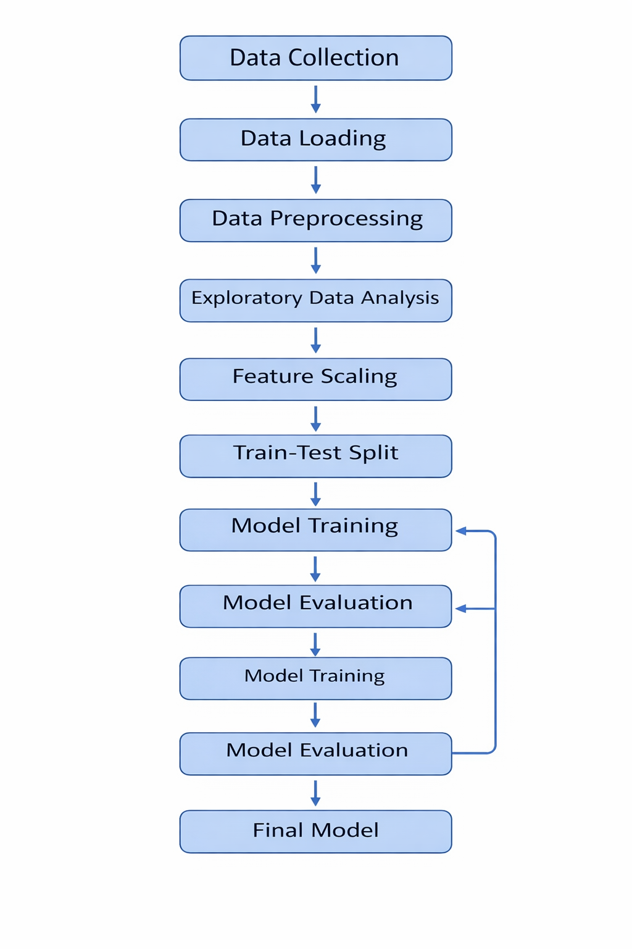

Fig. 1 Architecture Of this Project

1. Data Collection – The dataset containing smartphone sensor readings was collected and stored in CSV format.
2. Data Loading – The dataset is loaded into Python using the Pandas library for further analysis.
3. Data Preprocessing – Missing values are handled using mean and median replacement. Duplicate entries are removed.
4. Exploratory Data Analysis – Histograms, scatter plots, and heatmaps are used to understand relationships between variables.
5. Feature Scaling – StandardScaler is applied to normalize numerical features.
6. Train-Test Split – The dataset is divided into training and testing sets.
7. Model Training – Logistic Regression and Random Forest algorithms are used.
8. Model Evaluation – The trained models are evaluated using classification metrics.

- Expected Modules/ Libraries to be used :
• Pandas – For data manipulation and dataset handling.
• NumPy – For numerical operations.
• Matplotlib – For plotting graphs and visualizations.
• Seaborn – For advanced visualization like heatmaps.
• Scikit-learn – For machine learning algorithms and evaluation.

- Expected Evaluation metrics and Plots to be used:
Evaluation Metrics:
• Accuracy – Measures overall correctness of predictions.
• Precision – Measures correctness of positive predictions.
• Recall – Measures how well the model detects actual positives.
• F1 Score – Balanced evaluation metric combining precision and recall.

Visualization Plots:
• Histogram – Shows distribution of sensor values.
• Scatter Plot – Shows relationship between CPU usage and battery consumption.
• Heatmap – Shows correlation between different dataset features.

- Required topics from the subject:
Files – Used to read the dataset stored in CSV format.
Strings – Used for handling column names and categorical labels.
Libraries / Modules – Pandas, NumPy, and Scikit-learn used for ML implementation.

- Platform Required:
• Python
• Jupyter Notebook
• Anaconda / Python IDE
• Libraries: Pandas, NumPy, Matplotlib, Seaborn, Scikit-learn

- Books and Link Sources:
Books:
1. Hands-On Machine Learning with Scikit-Learn, Keras & TensorFlow – Aurélien Géron
2. Python for Data Analysis – Wes McKinney

Online Resources:
1. https://scikit-learn.org
2. https://pandas.pydata.org
3. https://www.kaggle.com
4. https://matplotlib.org

